**Behavior Expectations**

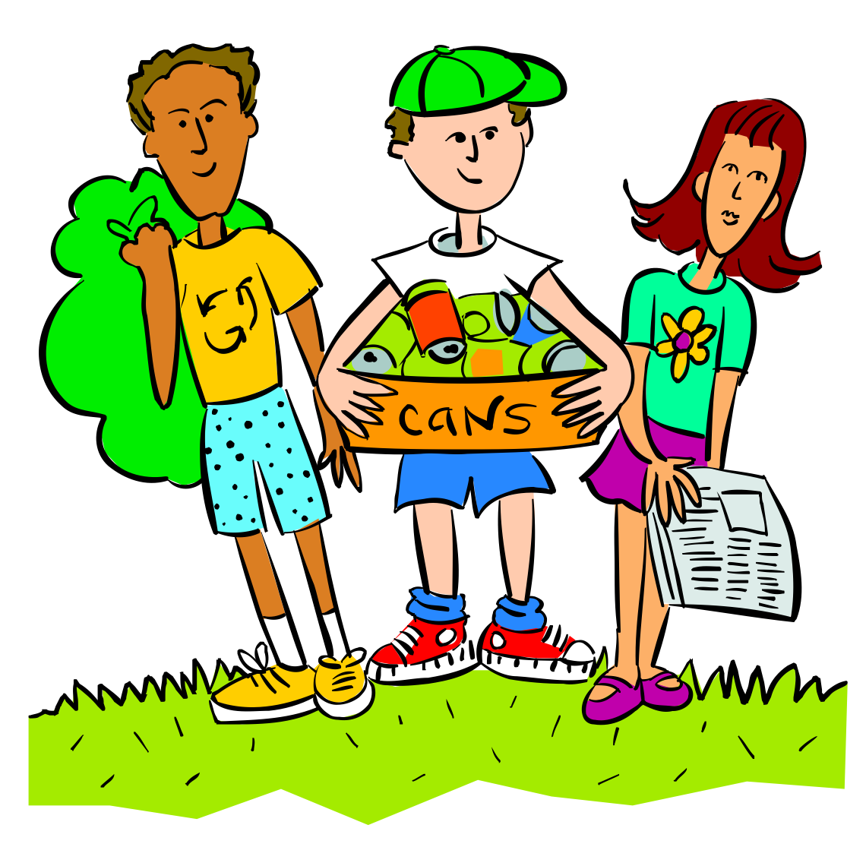

**Be Responsible**

* During class change, talk with a normal indoor voice.
* Pick up your belongings, trash, and notify a teacher if there is a spill.
* Report occurrence of vandalism.

**Be Respectful**



* Give space to others without crowding, bumping, or horse playing.
* Stop everything you are doing during the moment of silence and face the flag during the pledge of allegiance.
* Limit personal contact to hand holding.

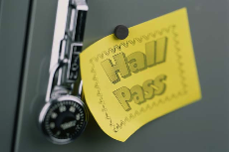**Be Ready**

* Hall pass required except during class change.
* Take care of locker needs quickly.
* Walk to class immediately after the warning bell rings.

**Be Safe**

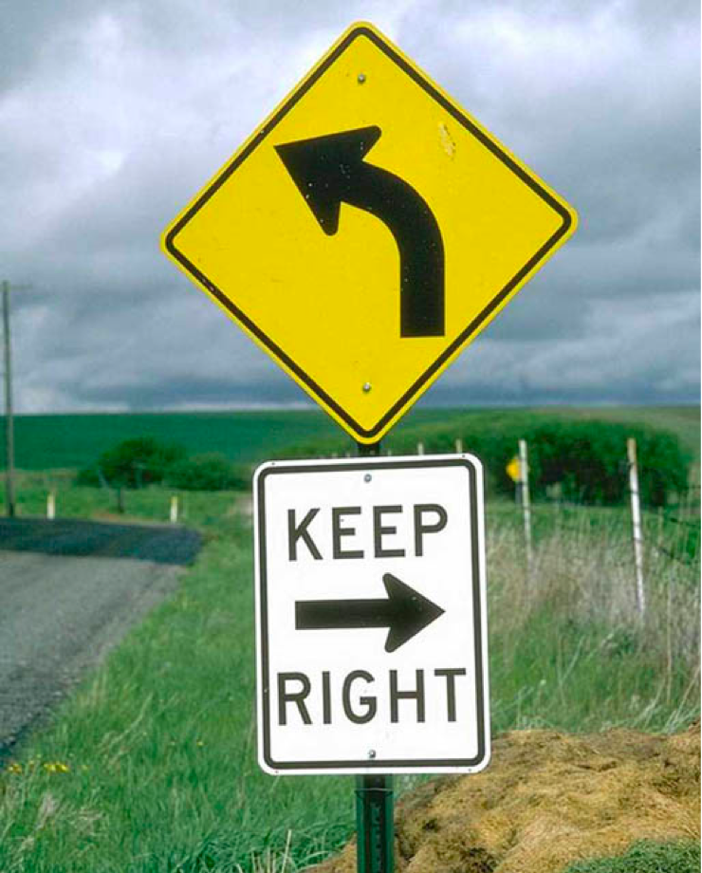

* Refrain from pushing, shoving, tripping others, and running.
* Walk with the flow of traffic on the RIGHT side of the hallway and stairs.
* Socialize along the perimeter of the hallways.