**Behavior Expectations**

**Be Responsible**

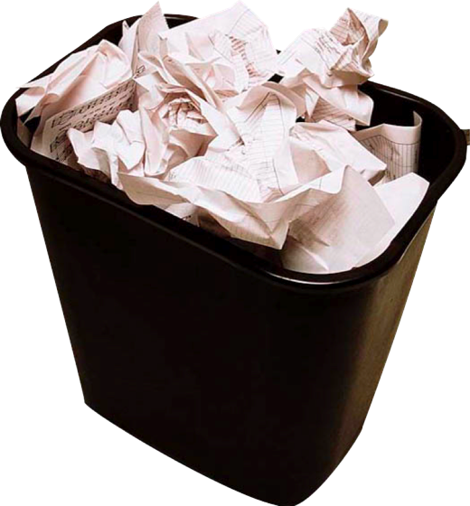

* Pick up trash in your locker area whether it belongs to you or not.
* Place all trash in proper receptacles.
* Use of a lock on your locker will prevent items from being removed without your knowledge and prevent unwanted materials being placed in your locker.

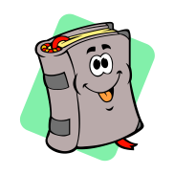

**Be Respectful**

* + Get necessary supplies out of your locker quickly.
  + Move out of the locker area in a timely manner so other students can move quickly to their lockers as well.
  + Keep only YOUR books and belongings in YOUR locker.

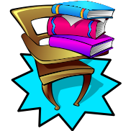

**Be Ready**

* Organize your locker to quickly find your books and materials.
* Keep up with and use only YOUR textbooks, notebooks, workbooks, etc.

**Be Safe**

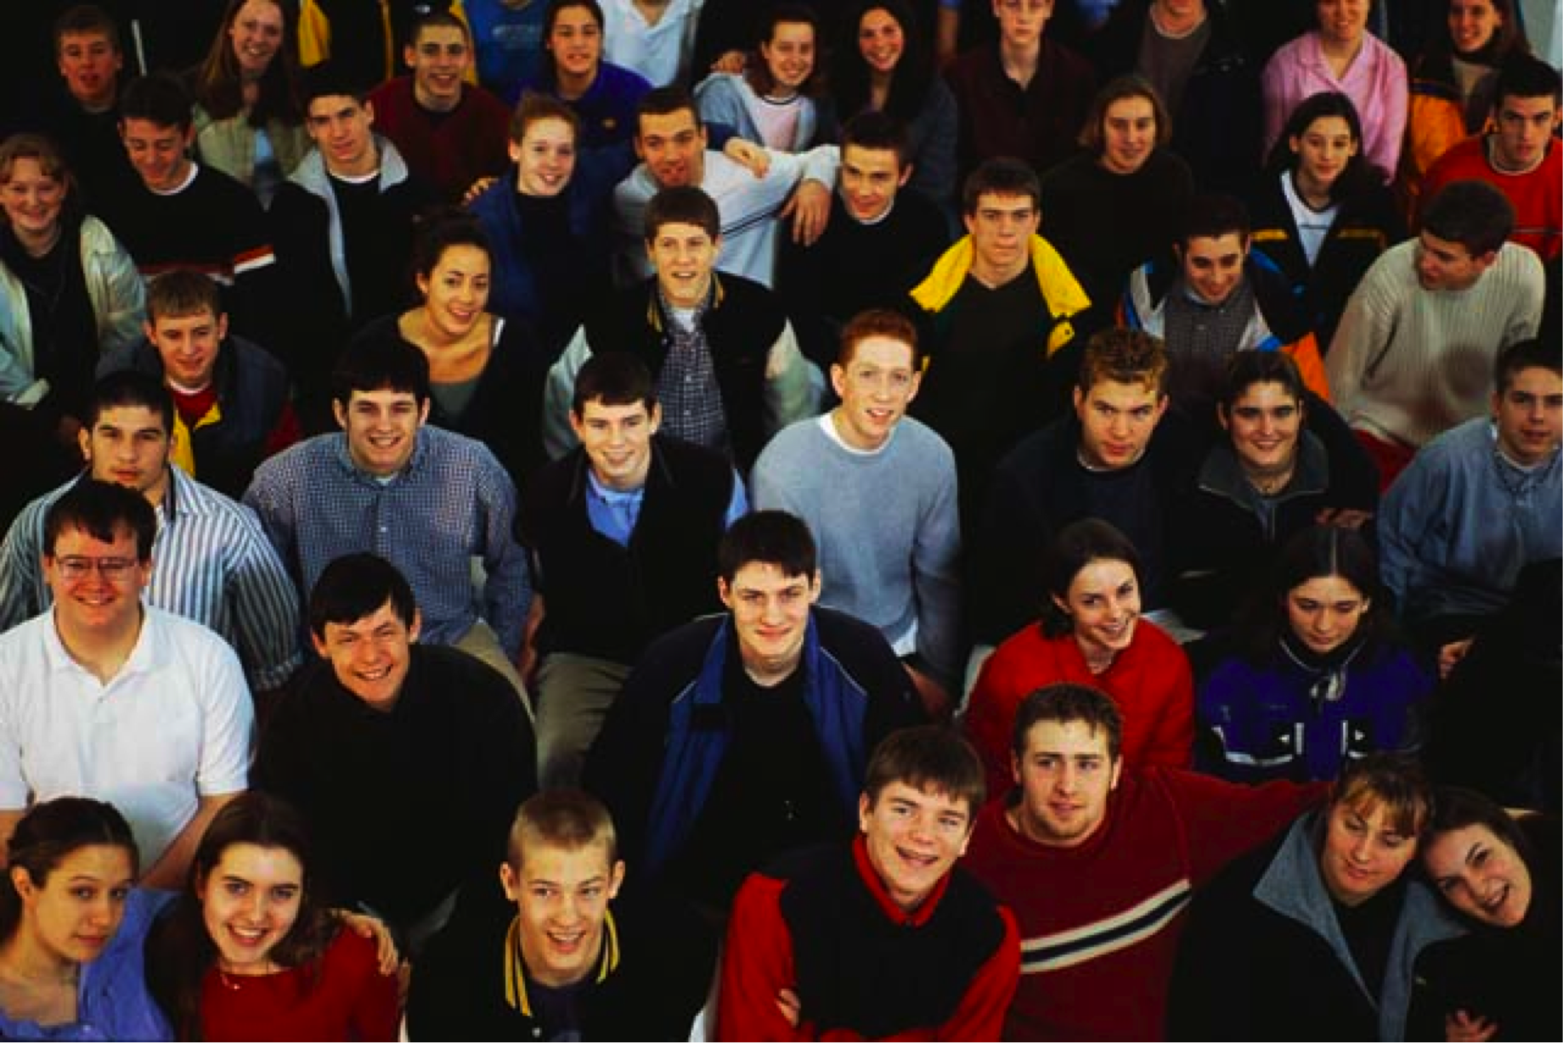

* Avoid crowding in locker area.
* Move in and out of locker area in a timely manner to prevent overcrowding.